**High Level Design (HLD)**

**Analyze International Debt Statistics**

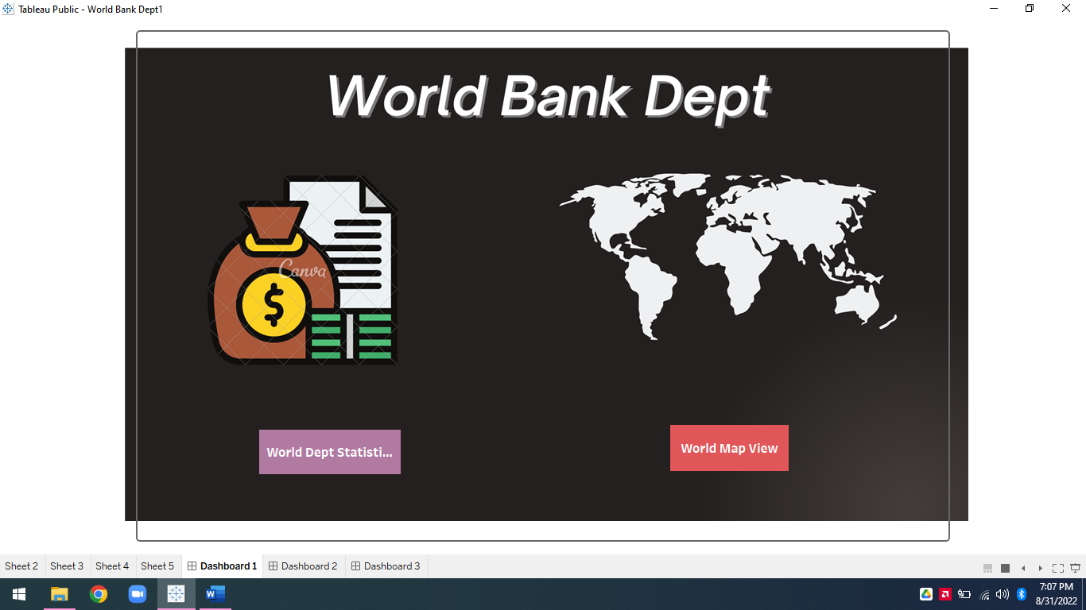

**Revision Number - 1.0**

**Last Date of Revision – 31/08/2022**

H HIGH LEVEL DESIGN (HLD)

**Document Version Control**

|  |  |  |  |
| --- | --- | --- | --- |
| **Date Issued** | **Version** | **Description** | **Author** |
|  |  |  |  |
| 31/08/2022 | 1.0 | Abstract, | Syed Ameer John SK |
|  |  | Introduction, |  |
|  |  | General Description  Initial Documentation |  |
|  |  |  |  |

**1|** P a g e

World Dept Bank Analysis



**2 |** P a g e

HIGH LEVEL DESIGN (HLD)

**Contents**

Document Version Control…………………………………………………………………………1

Abstract……………………………………………………………………………………………….3

1. Introduction……………………………………………………………………………………….3

1.1 Why this High-Level Design Document?............................................................3

1.2 Scope…………………………………………………………………………………..3

1. General Description……………………………………………………………………………….4 2.1 Product Perspective & Problem Statement……………………………………………4

2.2 Tools Used…………………………………………………………………………….5

1. Design Detail……………………………………………………………………………………...5

3.1 Functional Architecture………………………………………………………………..6

3.2 Optimization………………………………………………………………………….…7

1. KPI……………………………………………………………………………………………….…8

4.1 KPIs (Key Performance Indicators) ……………………………………………..…...9

1. Deployment……………………………………………………………………………………......10

 World Dept Bank Analysis



HIGH LEVEL DESIGN (HLD)

**Abstract**

The practice of evaluating an investment for profitability and risk is known as investment analysis. Its ultimate goal is to determine whether a certain investment is a good fit for a portfolio. It can also range from a single bond in a personal portfolio to a fledgling business investment and even large-scale corporate ventures.

Investment is a game of understanding historic data of investment objects under different events but it is still a game of chances to minimize the risk we apply analytics to find the equilibrium investment.

**1 Introduction**

**1.1 Why this High-Level Design Document?**

The purpose of this High-Level Design (HLD) Document is to add the necessary detail to the current project description to represent a suitable model for coding. This document is also intended to help detect contradictions before coding and can be used as a reference manual for how the modules interact at a high level.

**The HLD will:**

* Present all of the design aspects and define them in detail
* Describe the user interface being implemented
* Describe the hardware and software interfaces
* Describe the performance requirements
* Include design features and the architecture of the project
* List and describe the non-functional attributes like:

-Security

-Reliability

-Maintainability

-Portability

-Reusability

-Application compatibility

-Resource utilization

-Serviceability

**1.2 Scope**

The HLD documentation presents the structure of the system, such as the database architecture, application architecture (layers), application flow (Navigation), and technology architecture. The HLD uses non-technical to mildly-technical terms which should be understandable to the administrators of the system.

World Dept Bank Analysis **3 |** P a g e



HIGH LEVEL DESIGN (HLD)

**2 General Description**

**2.1 Product Perspective & Problem Statement**

The goal of this project is to analyse In this project, you are going to Analyse international debt data collected by The World Bank. The dataset contains information about the amount of debt (in USD) owed by developing countries across several categories. You are going to find the answers to

questions like:

1. What is the total amount of debt that is owed by the countries listed in the

dataset?

2. Which country owns the maximum amount of debt and what does that amount

look like?

3. What is the average amount of debt owed by countries across different debt

indicators?

The data used in this project is provided by The World Bank. It contains both national

and regional debt statistics for several countries across the globe as recorded from 1970

to 2015.

**2.2 Tools used**

Business Intelligence tools and libraries works such as NumPy, Pandas, Matplotlib, MS-Excel, Tableau, Jupyter Notebook and Python Programming Language are used to build the whole framework.

|  |  |
| --- | --- |
|  |  |
|  |  |
|  |  |

World Dept Bank Analysis 4**|** P a g e



HIGH LEVEL DESIGN (HLD)

1. Jupyter Notebook is used as IDE.
2. Python is the Programming Language used.
3. EDA is done using Numpy & Pandas.
4. Visualizations were done using Matplotlib & Seaborn.
5. Tableau is used for dashboard creation.

**3 Design Details**

**3.1 Functional Architecture**

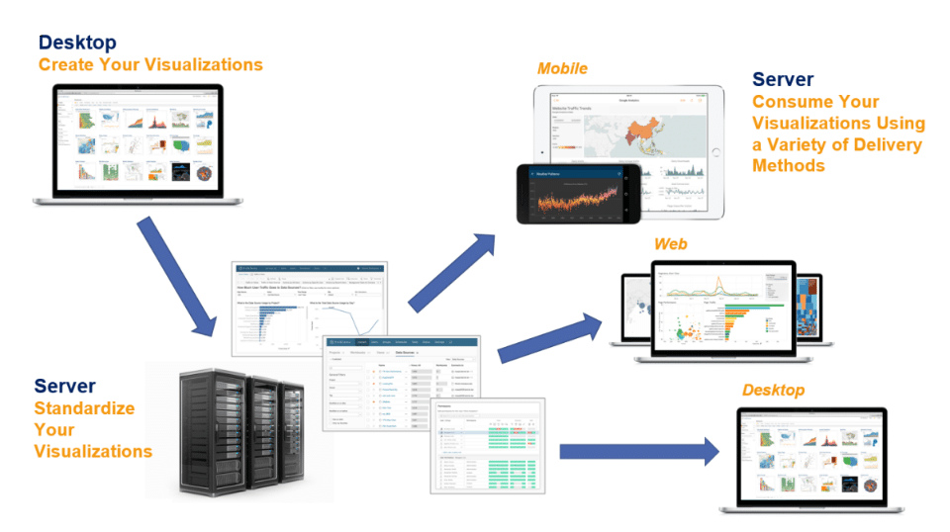

World Dept Bank Analysis **5|** P a g e



HIGH LEVEL DESIGN (HLD)

How does Tableau Work?

* Tableau connects to data sources, extract data into sources and make visualization of the data.
* There are two types of data extraction- 1) Live 2) Extract.
* Live data connectivity is about extract data lively (online), an analyst will work on data and share a dashboard with the user. Users can read the data using the tableau reader.
* Data extraction can be done from Tableau Desktop (offline) and it is published on Tableau Server. Users can access data using the Tableau server from any location.

**Assumptions**

It is a task that is We have to Analyse the data of the World Dept Analysis we have Many task like top country having more dept etc…

Our analysis assumes that all the data provided was true without any corruption and the features mentioned in the raw dataset are the only driving factors of a equilibrium investment.

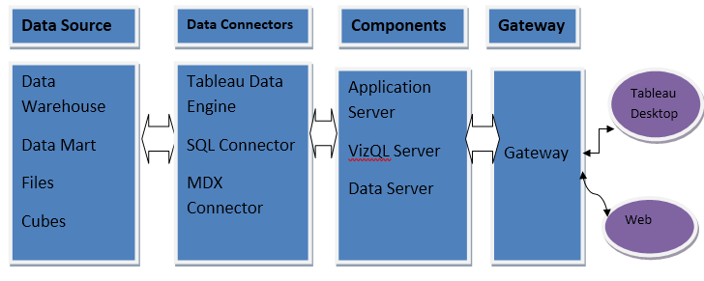

World Dept Bank Analysis 6**|** P a g e



IGH LEVEL DESIGN (HLD)

HIGH LEVEL DESIGN (HLD)

HIGH LEVEL DESIGN (HLD)

HIGH LEVEL DESIGN (HLD)

**3.2 Optimization**

1. **Your data strategy drives performance**
   * Minimize the number of fields
   * Minimize the number of records
   * Optimize extracts to speed up future queries by materializing calculations, removing columns and the use of accelerated views
2. **Reduce the marks (data points) in your view**
   * Practice guided analytics. There’s no need to fit everything you plan to show in a single view. Compile related views and connect them with action filters to travel from overview to highly-granular views at the speed of thought.
   * Remove unneeded dimensions from the detail shelf.
   * Explore. Try displaying your data in different types of views.

3.**Limit your filters by number and type**

* + - Reduce the number of filters in use. Excessive filters on a view will create a more complex query, which takes longer to return results. Double-check your filters and remove any that aren’t necessary.
    - Use an include filter. Exclude filters load the entire domain of a dimension while including filters do not. An include filter runs
    - much faster than an exclude filter, especially for dimensions with many members.
    - Use a continuous date filter. Continuous date filters (relative and range-ofdate filters) can take advantage of the indexing properties in your database and are faster than discrete data filters.
    - Use Boolean or numeric filters. Computers process integers and Booleans (t/f) much faster than strings.
    - Use parameters and action filters. These reduce the query load (and work across data sources).

World Dept Bank Analysis 7**|** P a g e



**Performance**

Investment analytics determines the historic all the previous data and it should be as accurate as possible. So that it will not mislead to the future investor. Also, model retraining is very important to improve the performance.

**Security**

Since the investment care analysis consists of years data, the information should be secured.

**Reusability**

The code written and the components used should have the ability to be reused with no problems.

**Resource utilization**

When any task is performed, it will likely use all the processing power available until that function is finished.

**4 KPI**

Dashboards will be implemented to display and indicate certain KPIs and relevant indicators for the Investment.

|  |
| --- |
|  |

As and when the system starts to capture the historical/periodic data for a Year, the dashboards will be included to display charts over time with progress on various indicators or factors

World Dept Bank Analysis 8**|** P a g e



**4.1 KPIs (Key Performance Indicators)**

HIGH LEVEL DESIGN (HLD)

HIGH LEVEL DESIGN (HLD)

Key indicators displaying a summary of the Investment Analysis and its relationship with different metrics

1. Country wise Dept, Total no of Dept Country
2. Which Indicator has maximum or minimum indicator.Total Sum of dept Country Wise.

**5 Deployment**

Prioritizing data and analytics couldn’t come at a better time. Your company, no matter what

size, is already collecting data and most likely analyzing just a portion of it to solve business

problems, gain competitive advantages, and drive enterprise transformation. With the

explosive growth of enterprise data, database technologies, and the high demand for

analytical skills, today’s most effective IT organizations have shifted their focus to enabling

self-service by deploying and operating Tableau at scale, as well as organizing, orchestrating,

and unifying disparate sources of data for business users and experts alike to author and

consume content. Tableau prioritizes choice in flexibility to fit, rather than dictate, your enterprise architecture. Tableau Server and Tableau Online leverage your existing technology investments and integrate into your IT infrastructure to provide a self-service, modern analytics platform for your users. With on-premises, cloud, and hosted options, there is a version of Tableau to match

your requirements. Below is a comparison of the three types:

TYPE PROS CONS

Tableau Server - On Premises

• Full control of hardware and software

• Infrastructure and data remain behind your firewall

• Need dedicated administrators to manage hardware and software

• Additional infrastructure needed to access off-network (mobile, external)

Tableau Server - Public Cloud (IaaS)

• Full control of software on managed hardware

• Puts infrastructure in same place as data (for migration to cloud)

• Flexibility to spin up/down hardware as needed

• Need dedicated administrators to manage software

• Additional infrastructure needed to access off-network (mobile, external)

Tableau Online (SaaS)

• Fully hosted solution (hardware, software upgrades)

• Fast to deploy

• Easy for external audience to access

• Single-site in multi-tenant environment

• Cubes are not supported

• No guest account access

World Dept Bank Analysis 9**|** P a g e



HIGH LEVEL DESIGN (HLD)

Depending on your organizational roles and responsibilities, Tableau Server should be

installed by a systems administrator and the designated Tableau Server Administrator in

coordination with the appropriate IT roles. For Tableau Online, you will integrate with your

existing technology and configure the site settings. The Data & Analytics Survey, completed

by business teams, identifies and prioritizes data use cases, audience size, and users. You

will use the information collected in both surveys to plan your deployment strategy, including

sizing, installation, and configuration of your Tableau Server or integration and configuration

of Tableau Online. In addition to installing Tableau Server or configuring Tableau Online,

administrators will also need to plan for the client software installation of Tableau Prep Builder,

Tableau Desktop, Tableau Mobile, and Tableau Bridge for Tableau Online where applicable.

The Dashboard is published on Tableau and an auto-refresh mode has been set so that the dashboard keeps on updating as the real time data loads into the log file.

The Dashboard showcases the multiple insights that has been drawn from the log files as follows:

**Country wise-** This dashboard contains **Country** wise Dept analytics on dataset like total Indicator, Country name.



**Indicator wise:** This dashboard shows indicator wise analytics on given dataset.

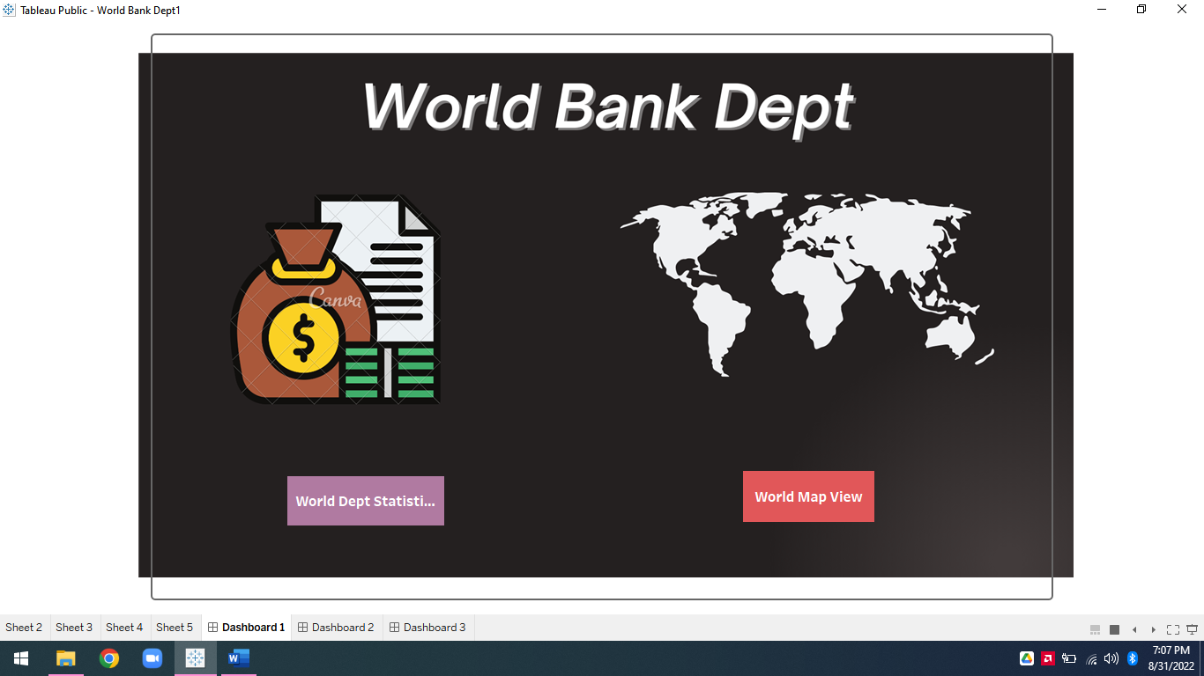

World Dept Bank Analysis 10**|** P a g e



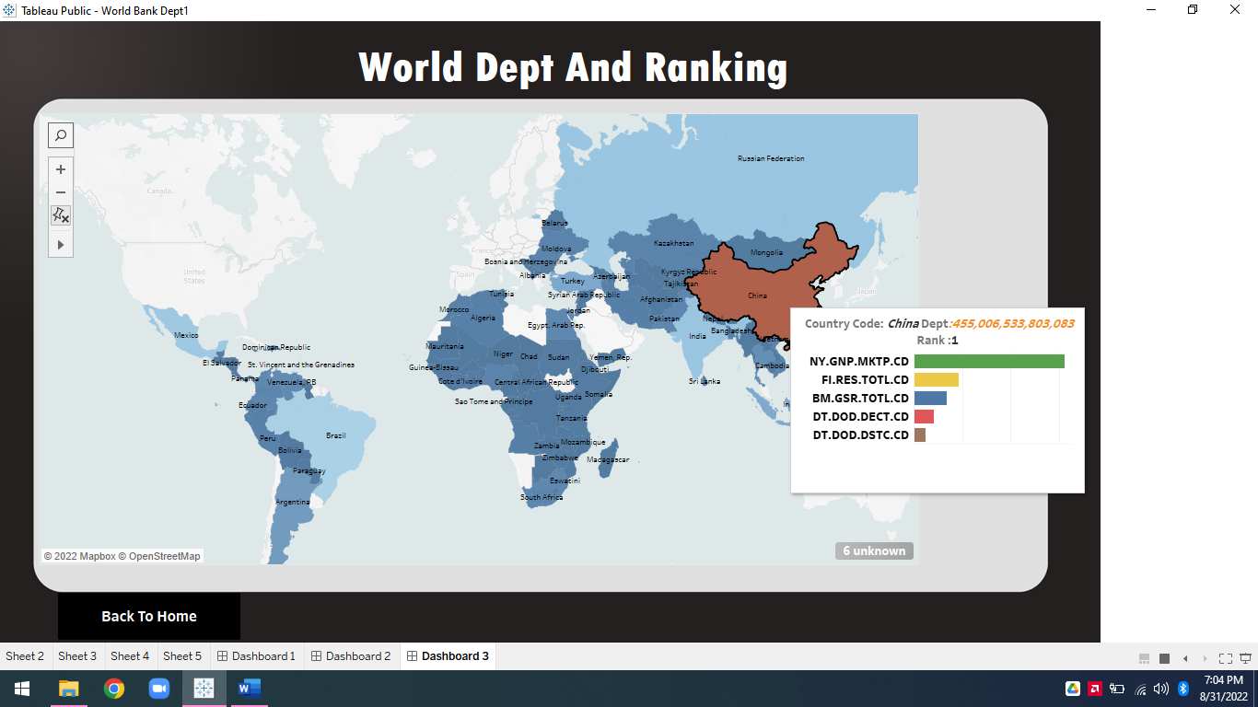

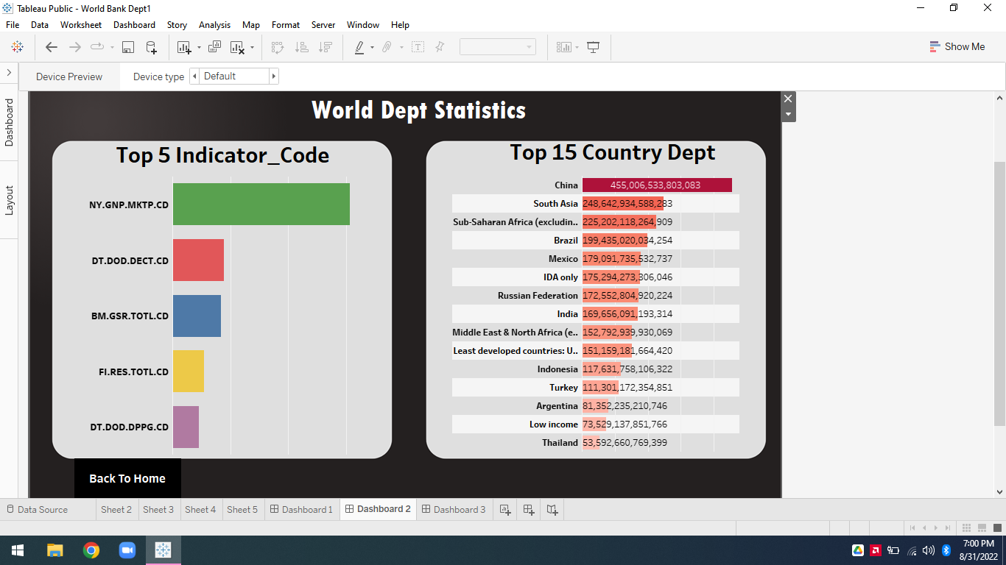

World Dept Bank Analysis 11**|** P a g e

